|  |  |
| --- | --- |
| Description | Comments |
| Register an account | * Cannot find it * Cannot find the sign-up button * Sign up function not available * I do not know what I’m supposed to sign up for, so it took me a while to even understand that I’m supposed to sign up for a slot to learn and play.  Maybe set a restriction for mobile phone to be 8 characters? I typed “12345” and the form accepted it. |
| Login | * No login button on home page although there is a login when you view available slots * Able to find login page but unable to find register button. However, can make login page link more obvious. * Need a Login button at the home page. * No Log out options * Username & Password, no need for ‘or email’ * After failed log in, how to go back to robostudio * Logging in encountered with an error * Can’t find it * No Sign up, no log in * Log in function not available. * A bit confusing because there is a “My Account” button and the top right-hand corner, but it’s for your Wordpress log-in. I clicked on that instead. |
| View available slot | * Pre-booked slots are greyed out (Good) but cannot select multiple time slot * “Play!” might not be the best word for it, especially if I’m trying to book a slot. * Bug caught, time now is 9.40, available slot for the game are 22:00 and 22:30, but when I click 22:00 it does not work |
| Select Game | * Unable to select multiple games * Game Alignment fucked up * Selected a game, from view games but still must select a game |
| Select Game Time Slot | * Error when a pre-booked slot is select * Day is wrong it should be 23rd Jan But it shows 24th Jan * Wrong date when click on “Today” * Can only book 1 week in advance max * Seems it is with the available slots * Would be nice to standardize the colour coding for availabilities etc (seeing the red, blue and green dates was slightly confusing at first without a legend – the selection of hour was clearer as it was either green or grey). * Maybe don’t show the weird timings like 00:00 hours, since you probably wouldn’t have sessions then. |
| Booking | * Booked without logging in, new account created * Address field is not validated * Email received but link not hyperlink |
| Choose game and review price | * Able to choose game and review price * Quite redundant as I’m asked to choose the game again? What was the point of view available slot then? * Can select 2 items at once and proceed to the next page? Suggest you all put error check if you’re going to stick with this page. * Seems to be together with the select of game * It was slightly confusing as I thought I had selected the game earlier but was asked to select the games again. Also, since only one time slot can be chosen, what happens if two games are selected?   I can select and pay for both games, but both games are half-an-hour each, but game time slots are in half-an-hour windows? So, if I booked 1600 and select both games, will the 1630 timeslot still be available for booking? If so that might be an error.  Also, I booked the 1630 timeslot but during checkout they showed 00:00. |
| Select Payment | * Able to select payment * Sand box take a bit long to load * Reached the select payment option (only has paypal) and after clicking paypal, got this. * Wording might consider changing for finalise to proceed to payment * Only PayPal option was available and an error page occurred without the option to return/retry. * Since I didn’t get to the payment page, I’m guessing I will be allowed to pay with credit card through your payment provider (PayPal). But the button name was “Pay with PayPal”. People might be misled to think they need a PayPal account to pay and just not do it entirely. Perhaps rename the button to just “Proceed with Payment” or something. |
| Confirmed booking? | * Yes, received email * Received email on pending payment. * Received confirmed booking slot after payment. * Cancelling booking pass * Did not provide sandbox sample of credit card, cannot go through |
| Booking Failure | * If cancel booking able to receive payment is not completed. |
| Cancel Payment | * Cancel payment but slot is not available for the canceled slot |
| Log out | * Why the name is default Howdy |

Other comments

* Pressing back brings me back to select game screen? Not sure it’s advisable.
* Also, got this screen your loading image

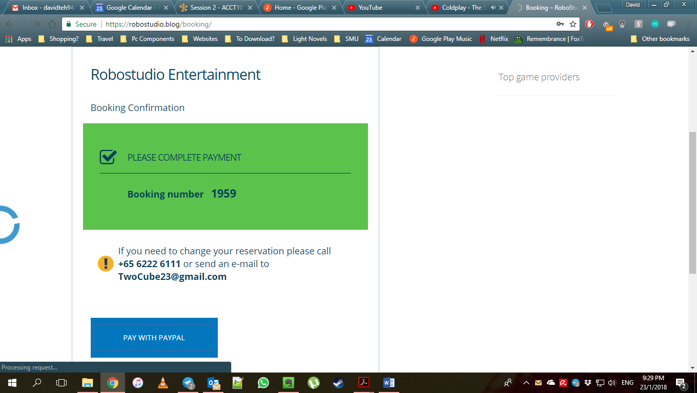

* I don’t know how many steps are there in your process. It seems to the user it is a never-ending loop, might cancel halfway when we are impatient.
* Why run your code! That link is linked back to homepage
* My account seems to be out of place, also why does my account only able to edit reservation, not my house address/telephone number, what if I shifted, or change number.
* A lot empty space, can consider to do something about it.